

Experiment 1
Private Cloud using OpenStack

AIM:

To create a private cloud environment by installing and configuring OpenStack (MicroStack) on a single Ubuntu system. The experiment also helps in learning how cloud resources such as virtual machines, networking, and storage are managed in a private cloud.

What is Openstack?
OpenStack is an open-source cloud platform used to build and manage cloud infrastructure. It is mainly used for Infrastructure as a Service (IaaS), where users can create and control virtual machines whenever required. It provides services for computing, networking, and storage in a cloud environment.

What is Microstack?

MicroStack is a lightweight version of OpenStack that runs on a single computer. It is mainly used for learning, testing, and small-scale development. Since it requires only minimal configuration, it is a good choice for beginners who want to understand how OpenStack works.

PROCEDURE:
Step 1:
Create a new Ubuntu virtual machine using Oracle VirtualBox with the following configuration:
- Memory: 8 GB RAM
- Processor: 4 CPU Cores
- Storage: 20 GB Virtual Disk
- 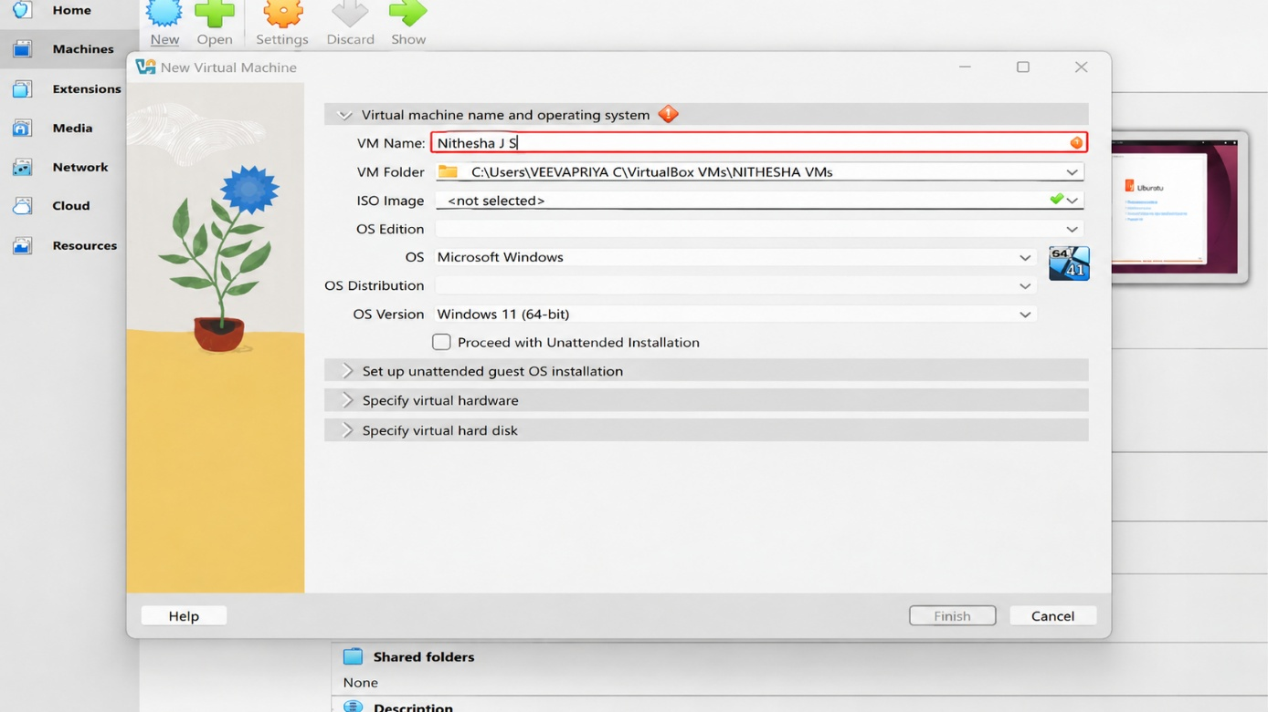
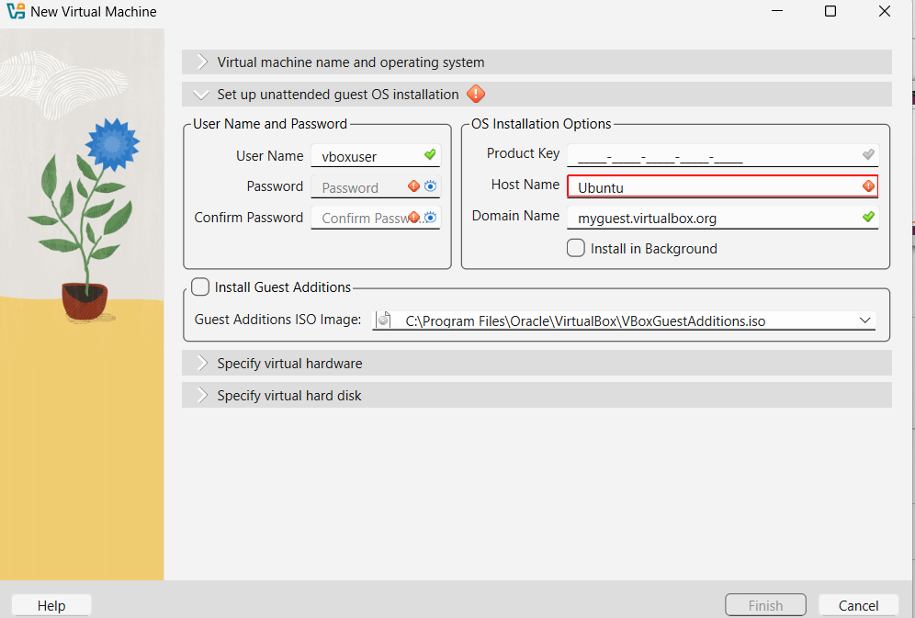

Step 2
Install the Ubuntu operating system and log in using the username and password created during installation.
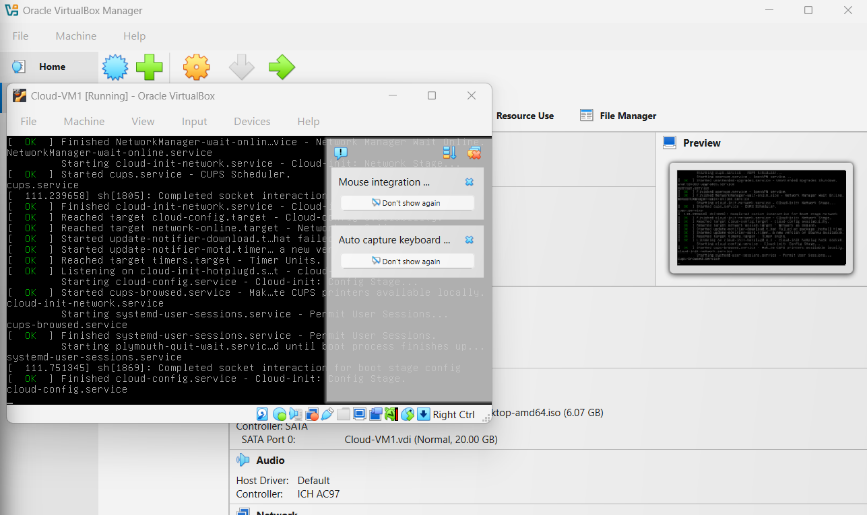
Step 3
Update the Ubuntu packages: sudo apt update
sudo apt upgrade
Step 4
Install MicroStack (Beta channel): sudo snap install microstack –beta
Step 5
Check whether MicroStack has been installed successfully.
snap list microstack
Step 6
Initialize the OpenStack services automatically by executing the following command.
sudo microstack init --auto --control

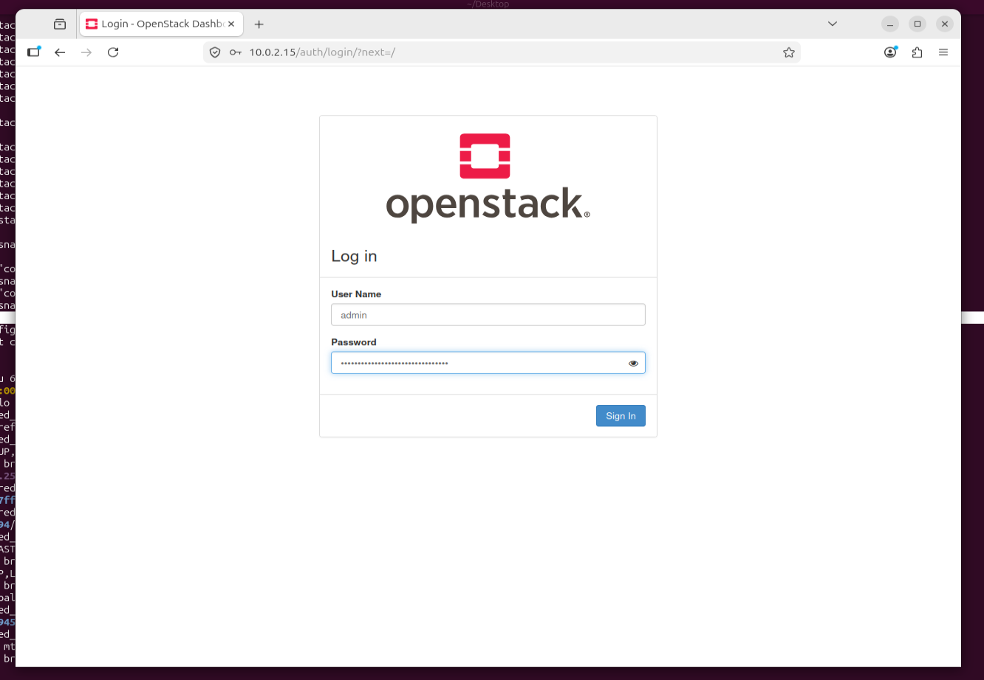
Step 7
Verify the installed OpenStack version:
microstack.openstack --version

Step 8
Retrieve the Keystone administrator password:
sudo snap get microstack config.credentials.keystone-password
Step 9
Open the OpenStack Horizon Dashboard in the web browser using the IP address provided after initialization and log in using:
  - Username: admin
  - Password: (obtained from the previous command)

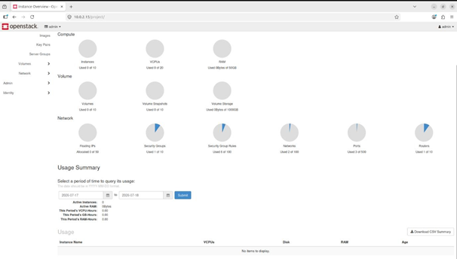

CONCLUSION:
OpenStack (MicroStack) was successfully installed and configured on Ubuntu, and the Horizon Dashboard was accessed.

